Log-Log Graphs

* The anti-log of the intercept yields the proportionality constant
* The slope of a log-log graph is the power of the original relationship
* Ex. y-intercept=5 and m=-2 🡪 y=100000x-2

Waves & Light

* Vibrations
  + Frequency (f)
  + Period (T)
  + Amplitude (a)
* Waves
  + Longitudinal, transverse, torsional
  + Pulse, periodic
* Universal Wave Equation: v=fλ
* Properties of Waves
  + Reflection
  + Refraction (bending of a wave as it enters a new medium; caused by ∆v)
  + Diffraction: bending of a wave as it passes through a barrier or through a gap in one (increase diffraction: decrease barrier’s geometry [smaller hole], increase wavelength)
  + Polarization: restricting vibrations of a transverse wave to a single plane
  + Interference: the resultant displacement at each point in a medium when waves meet is the algebraic sum of the individual displacements (Principle of Superposition)
* Standing Waves: produced by identical wave choirs moving through one another in opposite direction
* Nodes: positions of continuous zero displacement
* Antinodes
* Loops: Distance between two nodes
* Harmonics
* Fundamental
* Overtones

Diffraction of Light

* Diffraction effects were noticed by people (including Newton) but they were not recognized as diffraction
* J. Fresnel suspected that light may be a wave and developed a comprehensive mathematical wave theory
* S. Poisson believed light was not a wave and used Fresnel’s theory to show that a bright spot should occur in the middle of a shadow caused by diffraction
* Fresnel responded by taking Poisson’s analysis, pointing out that the theory requires a small object, and found “Poisson’s Bright Spot” through an experiment

Bright Spot

Huygen’s Wave Model

* Robert Hooke proposed the wave theory of light
* Huygen developed the theory further 20 years later, introducing Huygen’s principle for predicting the position of a wave front
* Huygen’s principle: Every point on a wave front can be considered as a point source if tiny secondary wavelets that spread out in front of thee wave at the same speed as the wave itself; the surface envelope, tangent to all the wavelets, constitutes the new wave front

Single Slit Interference

* Thomas Young Experiment
  + Single light source through two pinholes close together
  + Single fixed interference pattern

wsinѲn=nλ wsinѲm=(m+½)λ ym = mλL ∆y=L λ (note: width of centre fringe is 2∆y)

w w

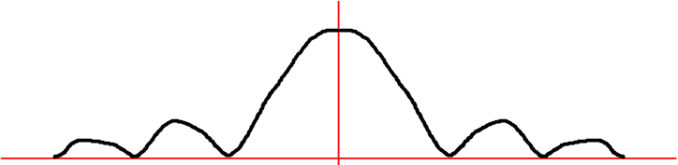

Two-Source Interference

* Increase Number of Nodes:
  + Increasing source separation
  + Decreasing wavelength

dsinѲn=(n- ½)λ =|PS2-PS1|=AS1 dsinѲm=mλ xn=(n-½)λL

d

* The distance between the right bisector and the length is so small that they are treated as equal

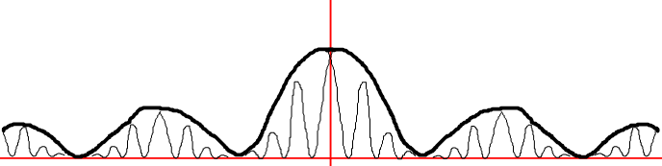

* Consider the horizontal distance between adjacent node lines (note: width of centre fringe is ∆x)

∆x=xn+1-xn

=(n+1-½)λL/d – (n-½ ) λL/d

=[(n+ ½) - (n–½)]λL/d

=λL/d

* Reflection and Transmission:
  + Fixed end: reflects inverted
  + Free end: reflects upright
  + Into a slow medium: transmits upright, reflects inverted
  + Into a fast medium: transmits upright, reflects upright

Air Wedge Interference

* t= Lλ

2∆x

Properties of Light

|  |  |  |
| --- | --- | --- |
| **Property** | **Particle Theory** | **Wave Theory** |
| Rectilinear Propagation | Since the path of light has no noticeable curve, light consists of particles at an extremely high speed | No adequate explanation: waves emitted from a point source spread out in all directions rather than traveling in a straight line (like light) |
| Finite Speed | ??? | ??? |
| Reflection | When a light particle is reflected, there is no change in horizontal components but the vertical component is reversed in direction because of the reactive force at the horizontal surface of the sphere, leaving its magnitude unchanged (follows laws of motion) | Waves obey the law of reflection from optics (Ѳi=ѲR) |
| Refraction | Particles will bend toward the normal if their speed increases and when light travels into water, it bends towards the normal (predicted the speed of light was faster in water) | Light bends towards the normal when it passes into an optically denser medium such as glass because the speed is slower in the denser medium |
| Dispersion | Since each particle in the spectrum has a different mass (violet being the least massive), different particles are refracted through different angles when white light passes through a glass prism, generating a display of spectral colour | Since white light is composed of many colours of the spectrum, each with a different wavelength, violet wavelengths are refracted more than red ones when light passes through a prism. |
| Interference | Not plausible | Waves interfere |
| Diffraction | A beam of light travelling through successive slits produces a band larger than the width of slits due to collisions between the light particles, light doesn’t bend around objects, Grimaldi’s slit from colliding particles | Since diffraction only becomes easy to detect when the apertures are of approximately the same size as the wavelength, diffraction will be minimal if the wavelength is extremely small unless the aperture is also extremely small (w≤λ) |
| Polarization | Not plausible | Property of transverse waves |
| Pressure | Light has a small mass | Unaware that light had a mass |
| Partial Reflection-Partial Refraction | “Theory of fits:” since some particles of light arrive at the surface sometimes in a fir of easy reflection or other times in a fit of easy refraction, some of the light refracts | For waves and light refracted away from the normal, when the speed increases, partial reflection also occurs (ѲC) |

Newton’s Particle Theory

* Explained rectilinear propagation, reflection, refraction, and dispersion
* Weak in its explanations of diffraction and partial reflection-partial refraction
* Did not explain interference and polarization

Huygen’s Wave Theory

* Explained reflection, refraction, partial reflection-partial refraction and diffraction
* Did not explain rectilinear propagation

Kinematics

* The slope of a displacement-time graph is the velocity
* The slope of a velocity-time graph is the acceleration
* The area under a velocity-time graph is the displacement
* The area under an acceleration-time graph is the velocity

Newton’s Laws

* Velocity remains constant unless acted upon by an external (net) force
* F=ma if the net force on an object is not zero
* For every force there is a reaction force equal in magnitude but opposite in direction

Projectile Motion: motion of an object that moves through the air along a trajectory without a propulsion system

* + Vertical components: u, v, a, d, and t
  + Horizontal components: d, v, and t

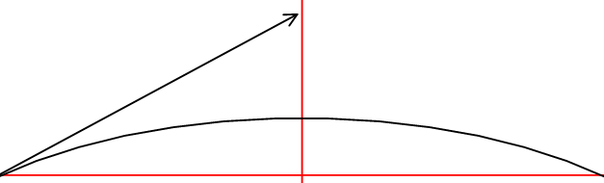

R=uV2sin2Ѳ t= 2uVsinѲ hMAX= uV2sin2Ѳ

g g g

* Centripetal Acceleration: Instantaneous acceleration of an object moving in a circle at a constant speed

aC=v2/r

aC=4π2r/T2

aC=4π2rf2

Dynamics

* Free Body Diagrams show all the forces acting on an object
  + Note: arrows always touch the objects on which they act
  + Push=pull
* Friction
  + Kinetic: occurs when surfaces slide past each other

Ff=μKFN

* + Static: occurs when surfaces are not moving relative to one another

Ff=μSFN

* + Ff=force of friction
  + μK=coefficient of kinetic friction (dependent of surface)
  + μS=coefficient of static friction (dependent of surface); force can be anything from zero to starting friction value determined by μS
  + FN=normal force
* Centripetal Force

FC=mv2/r

FC=m4π2r/T2

FC=m4π2rf2

* Note: for car-curve scenario FN=FC 🡪 mgtanѲ=mv2/r

Celestial Objects

* Stars
  + Rotate counter-clockwise about the North Star in one Siderial Day (24h – 4 min early)
  + If the horizon gets in the way, the stars rise and set
* Sun
  + Rises in the east and sets in the west in one solar day (24h)
  + 1 cycle = 1 year
  + 4 mins later than the stars (easterly drift with respect to the stars)
  + North-South drift (1 cycle = 1 year)
* Moon
  + Rises in the east and sets in the west (24h + 50 min late)
  + 50 additional minutes creates an easterly drift cycle and moon cycle (29 days; 1 month)
* Planets
  + Rise in the east and set in the west (times vary)
  + Generally drift eastward except for retrograde motion

Plato’s Problem

* To explain celestial motion in terms of circles and constant speeds
* Eudoxus (Geocentric)
  + Contemporary of Plato
  + Central stationary earth
  + Rotating celestial sphere
  + Sun on its own transparent shell (axis tipped to account for N-S motion; fixed celestial sphere with slower motion to account for easterly drift)
  + Planets on their own transparent shells (rotate in their own direction at their own rate)
  + Moon on its own transparent shell
  + Did not explain sight changes in motion (non-uniform)
  + Did not explain changes in brightness of planets
* Aristarchus (Heliocentric)
  + Celestial sphere remains fixed
  + Sun is at the centre
  + Earth and planets rotate around the Sun
  + The earth rotates about its own axis (daily motion) which is tipped (to explain N-S motion of the Sun)
  + Explained retrograde motion
  + Explained changes in brightness of planets
  + Earth was no longer special
  + No Stellar Parallax was measured
* Ptolemy (Geocentric)
  + Eccentric
    - Objects rotate about centre with uniform motion
    - Motion does not appear uniform from earth (describes the sun)

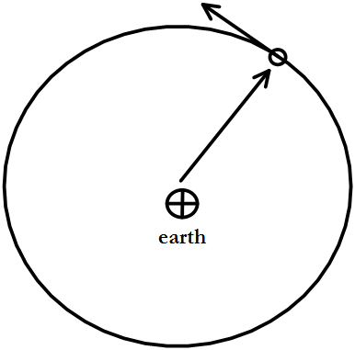

* + Epicycle
    - Planets rotate uniformly in small circles that rotate uniformly about earth (explains retrograde motion and changing brightness)

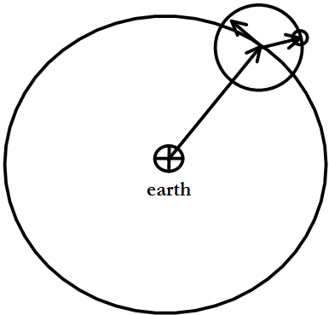

* + Equant
    - Planet rotates about centre
    - Motion is uniform about “+”
    - Explains different retrograde motions of different planets

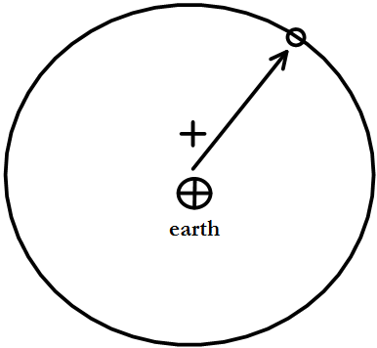

* Nicholas Copernicus (Heliocentric)
  + Sun is the centre of the universe
  + Earth and other planets rotate about the sun
  + Earth-sun distance (1a.u.) is much less than the distance to the stars
  + Daily rotation of earth causes many of the apparent motions in the heavens (rising in east and setting in west)
  + Retrograde motions of the planets explained by the motion of the earth around the sun
* Tycho Brahe
  + Made very accurate measurements of the positions of the sun, moon, planets, and stars over 25 years
  + Carefully specified the accuracy of his experiments
* Johannes Kepler
  + Tycho’s student
  + Realized it was impossible to make a circular orbit scheme for Mars that was consistent with Tycho’s measurements
  + Disagreement about 8 minutes of arch
  + Kepler’s Laws
    - Planets move in an ellipse with the sun at one focus
    - The line from the sun to the planet sweeps out equal areas in equal periods of time
    - The cubes of their average distance from the sun are proportional to the square of the period of the planets’ orbits around the sun
* Sir Isaac Newton
  + Every object in the universe attracts every other objet with a gravitational force
  + Every motion in the universe could be accounted for by this force
  + This represented a shift in emphasis from a description of motion (kinematics) to a physical mechanism for it (dynamics)
  + Fg=GMm/r2

Cavendish Experiment: the first experiment to measure the force of gravity between masses in the laboratory, and the first to yield accurate values for the gravitational constant and the mass of the Earth

* For any central body of mass *M* around which a body is in orbit:

  mv2 = GMm

r r2

v2 = GM

r

v = √(GM/r)

* Kepler's First Law of Planetary Motion: Each planet moves around the Sun in an orbit that is an ellipse, with the Sun at one focus of the ellipse.

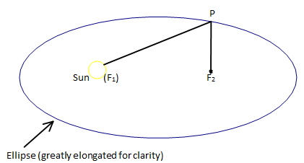

* Kepler's Second Law of Planetary Motion: The straight line joining a planet and the Sun sweeps out equal areas in space in equal intervals of time.

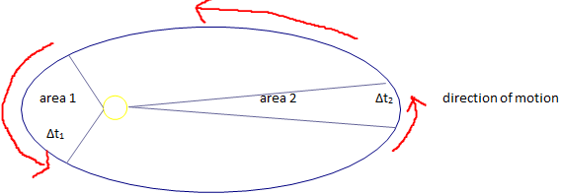

area1 = area2

∆t1 = ∆t2

d1<d2

* Kepler's Third Law of Planetary Motion: The cube of the radius *r* of a planet's orbit is directly proportional to the square of the period *T* of the planet's orbit.

r3 α T2

r3 = CST2

CS= r3/T2T = 2πr

v

T = 2πr__ (since v = √(GM/r))

√(GM/r)

T2 = 4π2r2

GM/r

T2 = 4π2r2(r)

GM

T2 = 4π2r3

GM

r3 = GM

T2 4π2

C = r3 = GM

T2 4π2

Momentum and Impulse

* The area under a force-time graph is the impulse
* Total impulse (impulse on the net force on a mass) is change in momentum
* Law of Conservation of Momentum: the total momentum of an isolated system remains constant
* Isolated system: a system on which there are no net external forces acting

Work

* Work is done when a force acts through a displacement
* Work is a scalar quantity
* The area under a force-displacement graph is the work done
* Total work done (work done through the net force on a mass) is equal to the change in kinetic energy
* Work-Kinetic Energy Theorem: the work done on a mass to change its speed equals its change in kinetic energy

Gravitational Potential

* Gravitational potential energy near earth is given by ∆Eg=mg∆h

Mechanical Energy and Elastic Potential Energy

* Law of Conservation of Mechanical Energy: the mechanical energy of a system is constant unless it is acted upon by an external force

Elastic Potential Energy in a Compressed (or Expanded) Spring

* Hooke’s Law: F=kx
* Ee=½kx2 where Ee is the elastic potential energy
* Mechanical energy in a spring involves kinetic, elastic, and gravitational potential energy

Momentum and Kinetic Energy

* Total momentum is conserved if a system is isolated
* Total momentum and total kinetic energy are conserved if a system is isolated and elastic
* Note: it is possible to conserve energy in a non-isolated system (ex. throwing a ball at a wall)
* Elastic collision:
  + The force one mass exerts on another is equal in magnitude to the force that it exerts back on the first
  + The work done on each mass by the elastic force exerted by the other is equal to the change in kinetic energy of that mass
* Note: total kinetic energy is temporarily lost during an elastic interaction, but it is conserved into potential energy so that total mechanical energy is conserved throughout
* The resultant angles add up to 900 when a collision is elastic and the masses are equal because the angles are Pythagorean: ½mu2 = ½mv12 + ½mv22 🡪 u2 = v12 + v22
* Special case: linear collisions in elastic collisions where one of the objects is initially at rest

Escape Criteria

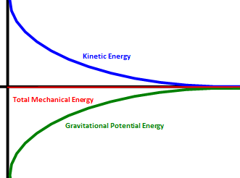

* ET=0
* Escape criteria: mass escapes and comes to rest at r=∞

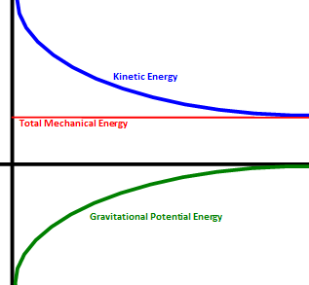

* ET>0 (positive)
* Mass escapes to r=∞ with excess kinetic energy (it keeps moving)

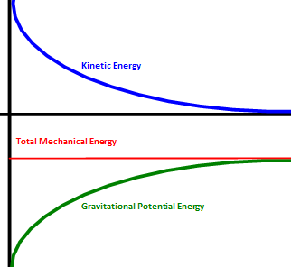

* ET<0 (negative)
* Mass is gravitationally trapped by M (it cannot escape)
* ET =½mv2–GMm/r

Effects of Gravity

* In an isolated system, the work done to change a separation from r1 to r2 is equal to the change in gravitational potential energy from r1 to r2.

area = √(F1∙F2)(r2-r1)

= √[(GMm/r12)(GMm/r22)](r2-r1)

= GMm(r2-r1)

r1r2

= GMm - GMm

r1 r2

∆Eg = E2 - E1

= GMm - GMm

r1 r2

= - GMm - -GMm

r2 r1

As r2 --> ∞, Eg2 --> 0, so if r2 is outside the gravitational field:

∆Eg = 0 - E1

= 0 - -GMm

r1

= GMm

r1

* Escape Speed: the minimum speed needed to project *m* from the surface *M* to just escape *M’s* gravitational force.

ET = EK + Eg = 0

EK = -Eg

½mv2 = - -GMm

r2

v =√(2GM/r)

* Escape Energy: the minimum kinetic energy needed to project a mass *m* from the surface of mass *M* to just escape the gravitational force of *M*.

EK = -Eg

½mv2 = - -GMm

r2

* Binding Energy: the amount of additional kinetic energy needed by a mass *m* to just escape from a mass *M* (the positive value of negative mechanical energy).

EB = -ET

= - (½mv2 - GMm/r)

* Energy of a satellite in circular orbit:

EK(SATELLITE)=½GMm 🡪 Fg=FC

r 2 2

ET(SATELLITE) = EK-Eg = ½GMm - GMm = -½GMm

r r r

EBINDING(SATELLITE)=|ET(SATELLITE)|=½GMm

r

Simple Harmonic Motion: a periodic motion in which the restoring force (and the acceleration) is proportional to the displacement

* For a simple pendulum: k=mg/l 🡪 T=2π√(l/g)

Electricity Review

* Law of charges
  + Like (positive or negative) charges repel
  + Unlike (positive and negative) charges attract
* Charge is a measure of change (due to friction, conduction, or induction)
* Neutral objects have an equal number of charges
* Most changing is due to electrons
* Conductor: easy electron movement
* Insulator: resists electron movement

Electrostatic Forces

* Traditionally, we pretend that charges move from positive to negative
* Electric Field Strength: the amount of force per unit charge at a given point

Fe=qЄ

* Coloumb’s Law: FE=kQq/r2
* Potential difference: the electric potential energy per unit charge

V=E/q V=Є∙d

* + Electric potential is a scalar quantity
* If two charged plates are separated double their initial separation
  + Charge remains constant
  + Electric field remains constant
  + Voltage doubles (V=Є∙d)
* If two plates connected to a constant voltage battery are moved to double their initial separation distance
  + Charge decreases by ½
  + Electric field decreases by ½
  + Voltage remains constant
* Electric fields between plates are constant
  + The force on a charge between two plates is the same everywhere
  + Lines are equally spaced and perpendicular to the plate
* Electric field strength depends only on the charge density on the plates

Millikan Oil Drop Experimentdetermined the fundamental unit of charge (the minimum electric charge carried by a particle)

Faraday discovered that changing magnetic field can induce an electric current

Oersted discovered electric currents produce magnetic fields

J.C. Maxwell built a mathematical model of electric and magnetic fields, based on Faraday’s idea of electric and magnetic “lines of force”

Einstein’s Postulates

* Principle of relativity: all the laws of physics are valid in all inertial frames of reference
* Constancy of the speed of light: the speed of light in empty space is c=3.00x108m/s for all observers in all inertial frames of reference
* Consequences
  + Moving clocks run slow
  + Moving objects are shortened
  + Simultaneous events are not observed as simultaneous bo other observers
  + Laws of space and time are altered
  + Laws of mechanics are altered
  + Definitions of energy and momentum must be changed if the conservation laws are to hold true

Time Dilation

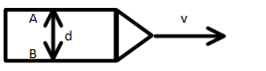



* Synchronized clocks (initially t=tP=0)
* Man A fires a flashbulb at tP=0
* Man B measures the time for the flash to reach him
* In their frame of reference:  d=ctP where c=speed of light
* In our frame of reference: 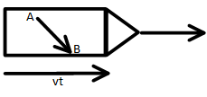 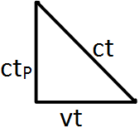 (ctP)2+(vt)2=(ct)2
* Light must travel further: therefore it must take longer
* Time Dilation: tP=t√(1-(v2/c2))

Length Contraction

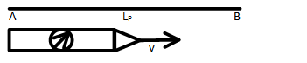

* In our frame of reference: LP=vt
* In their frame of reference tp=t√(1-(v2/c2))
* The relativistically shortened distance between the planets is given by

L=vtP

=vt√(1-(v2/c2)) 🡪 vt=LP

* Length Contraction: L=LP√(1-(v2/c2))

Mass Increase

* Using the Newtonian concept of Conservation of Mementum, Einstien showed that the mass of an object changed with its speed

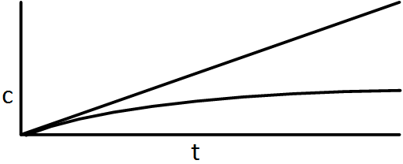

M= mP___

√(1-(v2/c2))

Where m=mass and mP=rest mass

* The mass of a moving object increases with speed
* The equation implies that no matter can travel at the speed of light because its mass would become infinite
* As an object is accelerated and its speed becomes a significant portion of the speed of light, the unbalanced force no longer goes into just increasing the velocity but into increasing the mass as well (EK=½mv2)

P= mPv ___ EK=mPc2[1/√(1-(v2/c2))-1] EREST=mPc2 ETOTAL= mPc2___

1/√(1-(v2/c2)) 1/√(1-(v2/c2))

* A rapidly moving object has a kinetic energy greater than ½mv2.

Modern Physics

* Democritus: first proposed that all existence is comprised of atoms and the void
* Roger Bacon: attempted to set forth a method of experimentation and observation
* William Gilbert: demonstrated that when objects are rubbed they attract small bits of matter
* Nicolo Cabeo: discovered repulsion
* Benjamin Franklin: showed that light is electricity
* George Coulomb: discovered that the force between charges varies inversely with the square of the distance between them
* A. Lavoisier: Law of Conservation of Mass
* Joseph Priestly: Matter is composed of compounds formed by elements and the Law of Conservation of Proportion

1. What was known from Chemistry

* Dalton’s Atomic Theory (~1810)
  + Matter is composed of unchanging, indivisible atoms
  + Elements have unique atoms
  + Compounds are composed of different atoms
  + Chemical reactions are rearrangements of atoms
* Explained known chemical Laws
  + Law of Conservation of Mass
  + Law of Definite Proportions
  + No idea why (atomic structure etc.)

1. From Physics

* Types of charge and Law of Charge (by 1850)
* Motion of charges in electric and magnetic fields (by 1850)
* Maxwell’s Law of Electromagnetism (by 1870)
* Cathode Rays: beams of electrons
  + Julius Plucker (1860): had two electrodes sealed in cathode tubes, set up an electric potential between them, and succeeded in driving a current across. The current produced glowing effects within the tube, and those effects changed according to quality of the vacuum chamber. If the vacuum was very good the glow would fade out, but the glass of the tube around the anode gave off a green light. He essentially discovered the cathode ray

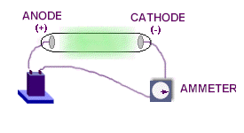

* + Sir William Crooke (~1875): designed a Crookes Tube, in which the electric current through a vacuum could more easily be studied. It seemed quite clear that the electric current started at the cathode and traveled to the anode, where it struck the neighbouring glass and created the glow of light. Crookes demonstrated this by placing a piece of metal in the tube and showing that it cast a shadow on the glass on the side opposite the cathode. (The electrical experimenters of the eighteenth and nineteenth centuries, beginning with Benjamin Franklin, had assumed that the current flowed from the concentration arbitrarily named positive to that named negative. Crookes had now shown that, in actual fact, the assumption was wrong and that the flow was from negative to positive.)

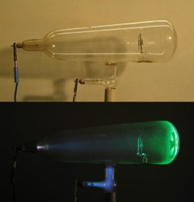

* + J.J. Thomson (1895): showed cathode ray deflection in an electric field and it had to be accepted that the cathode rays were streams of particles carrying a negative electric charge. The amount by which the cathode ray particle is deflected in a magnetic field of given strength is determined by its mass and by the size of its electric charge. Thomson was therefore able to measure the ratio of the mass to the charge, though he couldn't measure either separately. The smallest mass known was that of the hydrogen atom, and of the cathode-ray particle was assumed to have that mass it would have to carry an electric charge hundreds of times greater than the smallest charge known (that on the hydrogen ion). If, on the other hand, the cathode-ray particle was assumed to have the minimum charge observed in ions, then its mass would have to be only a small fraction of that of the hydrogen atom. If this charge were carried by the cathode-ray particle, it would have to be only 1/1837 as massive as a hydrogen atom. It was thus the first of the *sub-atomic particles* to be discovered.
* Properties of Cathode Rays:
  + Act as a negative charge in electric and magnetic fields
  + Travel in straight lines
  + Exert pressure on targets (i.e. had momentum)
  + Targets heat up
  + Properties independent of cathode materials or gases passed through
  + Some of the targets experienced chemical changes
* Thomson`s q/m experiment: discovery of the electron
  + Hypothesized that cathode rays were negatively charged particles
  + Applied a magnetic field

FM=ma

qvB=mv2

r

q =v

m Br

½mv2=Fd

=Vq

* + Add on electric field so that FE=FM

FE=FM

qV=qvB

d

v=V

Bd q= V__

M Bd/(Br)

= V_

B1B2dr

= V__

kI1kI2dr

= V__

K2I1I2drB=μ0n∙I

L

μ0n=k=5.12x10-3T/A

L

* Results and speculation: measure q/m for H+
* Discovered that q/m (H+)<<qe/mC
* Assuming q(H+)~qe
* Implied me<<m(H+)
* Photoelectric Effect led to:
  + Thomson Raisin Bun model of the atom after Gold Foil Experiment
  + Rutherford Planetary model (with a small positive nucleus)
* For a Given Metal
  + The photoelectric effect occurs only if the frequency is above a certain threshold frequency (f0)
  + The photoelectric current is proportional to the light intensity
  + Photoelectrons are released immediately
  + The maximum kinetic energy of the photoelectrons is proportional to the frequency and independent of the intensity of the light

Einstein’s Explanation

* A development of the work of Max Planck who studied the light and heat which was emitted by very hot bodies (blackbody radiation)
  + Energy of light is concentrated or “quantified” in lumps called photons

E=hf

* E: energy of a single photon
* h: Planck’s constant (6.6x10-34Js)
* f:frequency of light
* Einstein suggested that a single light photon, if it has sufficient energy, can eject a single electron from a metal sheet

hf=W+EK

* E=hf: energy of a single photon
* W: work function
* EK: kinetic energy of a photon
* Notes
  + - hf>W in order for the photoelectric effect to occur
    - greater amounts of photons eject greater numbers of electrons
    - The first photon can eject an electron (starts instantaneously)
    - When hf>W, the excess energy goes toward the kinetic energy of the ejected electrons

Matter Waves

* Louis de Broglie: suggested that regular matter could exhibit wave behaviours

λ =h/P λ =h/Pmv 🡪 de Broglie wavelength

½mv2=qV

v=√(2qV/m)

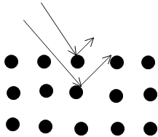

* Frank Herz Experiment: confirmed the nature of the Bohr atom
* Hydrogen Atom 🡪 Bohr (1912-1913)
  + Atoms could exist in stationary or non-radiating states
  + Radiation was emitted or absorbed when atoms changed from one stationary state to another (E1-E2=hf)
* Quantitative Treatment
  + Circular Orbit (mv2/r = kQq/r2)
  + De Broglie wavelength 🡪 (nλ=2πrn)

P=h/ λ🡪 λ=h/mv

En=-13.6eV

n2

Hydrogen Atom Spectrum

* Balmer Series (1885) 🡪 λ=b(n2/(n2-22)) where b=3.646x10-7m and n=3, 4, 5,...
* Rydberg Adaptation 🡪 1/λ=RH(1/m2-1/n2) where RH=4/b; m=2 and n=3, 4, 5,...
  + This experiment accounts for other series as well
  + m=1; n=2, 3, 4,... 🡪 Lyman (1906) (UV)
  + m=3; n=4, 5, 6,... 🡪 Paschen (1908) (IR)
  + m=4;n=5, 6, 7,... 🡪 Brackett (1922)
  + m=5; n=6, 7, 8,... 🡪 Pfund (1924)

The Physics of Photons

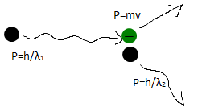

* Compton Effect: momentum and energy are conserved in collisions between photons and particles (i.e. electrons)

E=hf f=c/λ e=hc/λ

* Momentum of Photons

P=mv

=(E/c2)v

=(hf/c~~2~~)~~c~~E=mc2

M=E/c2P=hf/c

=h/λ